**LAB REPORT**

**ON**

**java PROGRAMMING**

**Phase II**

**By**

**Rupesh mahat**

**Exam Roll No: 8659/18**



**Submitted to:**

**Nimesh Pokhrel**

**Department of Computer Science**

**Kantipur College of Management and Information Technology**

**In partial fulfillment of the requirements for the Course**

**java Programming**

**Mid Baneshwor, Kathmandu**

**December 2021**

# Write programto use access control in java.

## Source Code

class Access

{

int a;

public int b;

private int c;

void set(int i)

{

c=i;

}

void show()

{

System.out.println(c);

}

}

class access_control

{

public static void main(String[] args) {

Access ob=new Access();

ob.a=10;

ob.b=20;

/*ob.c=30; error*/

ob.set(30);

System.out.println(ob.a+""+ob.b+"");

ob.show();

}

}

## Output Window

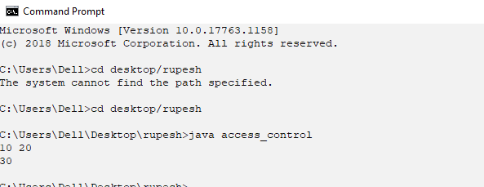

# Write program to display average.

## Source Code

import java.util.Scanner;

class average

{

public static void main(String[] args) {

int a,b,c;

Scanner s=new Scanner(System.in);

System.out.print("enter 3 numbers: ");

a=s.nextInt();

b=s.nextInt();

c=s.nextInt();

float avg=(a+b+c)/3;

System.out.println("average is: "+avg);

}

}

## Output Window

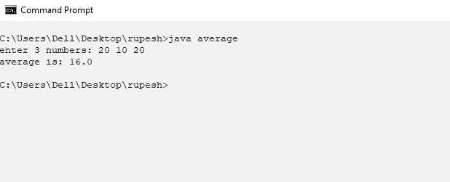

# Write program to use break.

## Source code

class break_as_goto

{

public static void main(String[] args) {

boolean b =true;

first:

{

second:

{

third:

{

System.out.println("Before break");

if(b)

break third;

System.out.println("This won't execute");

}

System.out.println("This won't execute");

}

System.out.println("Out of second level");

}}

}

## Output window

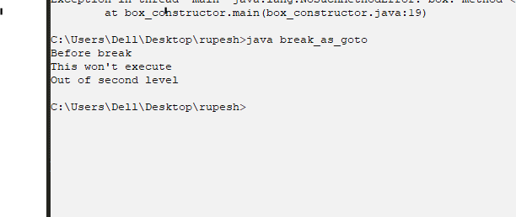

# Write program to terminate break.

## Source code

class break_terminateloop

{

public static void main(String[] args) {

int i;

for(i=0;i<100;i++)

{

if(i==10)

break;

System.out.print(i+"");

}

System.out.println();

System.out.println("Loop Completed");

}

}

## Output window

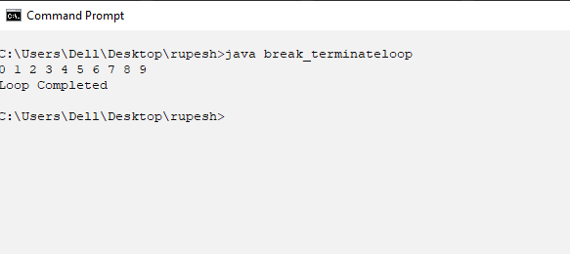

# Write program to call by value.

## Source code

class argument_pass

{

void set (int i, int j)

{

i*=5;

j+=5;

}

}

class call_by_value

{

public static void main(String[] args) {

argument_passob = new argument_pass();

int p = 10; int q = 20;

System.out.println(p+""+q);

ob.set(p,q);

System.out.println(p+""+q);

}

}

## Output window

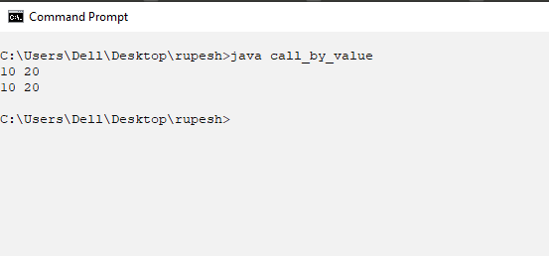

# Write a program that display Ambiguity in varargs method.

## Source code

class clg

{

static void display(double... contact)

{

System.out.println("Contacts are: ");

for(double d: contact)

System.out.println(d+"");

System.out.println();

}

static void display(String cname,double... contact)

{

System.out.println("Name: "+cname+"Contacts: ");

for(double d: contact)

System.out.println(d+"");

System.out.println();

}

static void display(boolean... b )

{

System.out.println("Values are: ");

for(boolean x:b)

System.out.println(x+"");

System.out.println();

}

public static void main(String[]args)

{

display();/*ambiguity occurs*/

display("KCMIT",8525930,440666);

display("NCC");

display(44544);

display(true,false,true);

}

}

## Output window

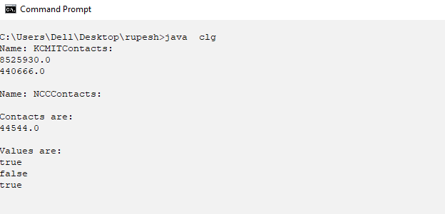

# Write program that take college name and display.

## Source code

class college

{

String name,address;

int rank;

void set(String n, String add, int r)

{

name = n; address = add; rank = r;

}

void show()

{

System.out.println(name+""+address+""+rank);

}

}

class college_demo

{

public static void main(String[] args) {

college c[] = new college[5];

int i;

for (i=0;i<5;i++) {

c[i] = new college();

}

c[0].set("KCMIT","Baneshwor",13);

c[1].set("ABC","Bhaktapur",12);

c[2].set("Orchid","Sinamangal",11);

c[3].set("Global","Baneshwor",15);

c[4].set("Apex","Mid-Baneshwor",14);

for (i=0;i<5;i++) {

c[i].show();

}

}

}

## Output window

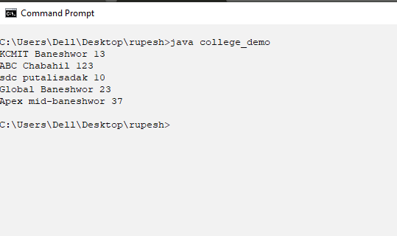

# Write a program that take college name and display using this keyword.

## Source code

class college

{

String name,address;

int rank;

void set(String name, String address, int rank)

{

this.name = name;

this.address = address;

this.rank = rank;

}

void show()

{

System.out.println(name+""+address+""+rank);

}

}

class college_demothis

{

public static void main(String[] args) {

college c[] = new college[5];

int i;

for (i=0;i<5;i++) {

c[i] = new college();

}

c[0].set("KCMIT","Baneshwor",13);

c[1].set("ABC","Bhaktapur",12);

c[2].set("Orchid","Sinamangal",11);

c[3].set("Global","Baneshwor",15);

c[4].set("Apex","Mid-Baneshwor",14);

for (i=0;i<5;i++) {

c[i].show();

}

}

}

## Output window



# Write a varargs program.

## Source code

class command_line

{

public static void main(String[] args) {

int i;

for(i=0;i<args.length;i++)

System.out.println("args["+i+"]: "+args[i]);

}

}

## Output window

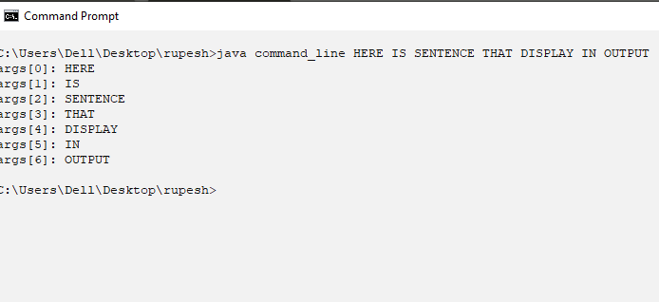

# Write a programto use continue in program.

## Source code

class continue_example

{

public static void main(String[] args) {

int i;

for(i=0;i<10;i++)

{

System.out.print(i+"");

if(i%2==0)

continue;

System.out.println();

}

}

}

## Output window

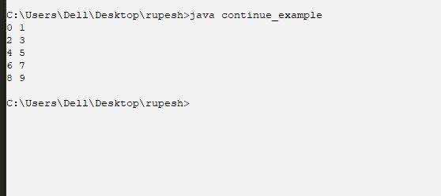

# Write a program of Do while example.

## Source code

class do_while_demo

{

public static void main(String[] args) {

int n = 10;

do{

System.out.print(n+"");

n--;

}

while(n>=0);

}

}

## Output window

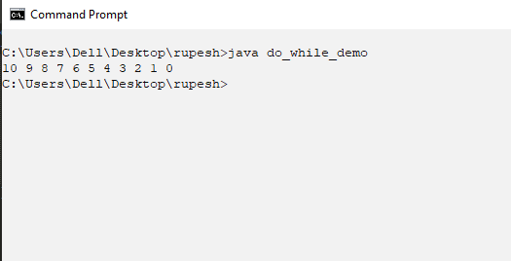

# Write a program that take doctors details.

## Source code

class doctor{

String specilization;

int reg_no;

int PAN;

void set_value(String s,intr,int p)

{

specilization = s;

reg_no = r;

PAN = p;

}

void display()

{

System.out.println("specilization is: "+specilization+

"reg_no is: " +reg_no+ "PAN"+PAN);

}

}

class method_parameter

{

public static void main(String[] args) {

doctor d=new doctor();

d.set_value("dentist",5646,11234);

d.display();

}

}

## Output window

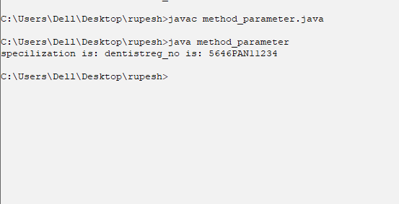

# Write a factorial program .

## Source code

class factorial

{

int fact(int n)

{

if(n==1)

return 1;

else

return fact(n-1)*n;

}

}

class factorial_example

{

public static void main(String[] args)

{

factorial ob = new factorial();

System.out.println("Factorial of 5: "+ob.fact(5));

}

}

## Output window

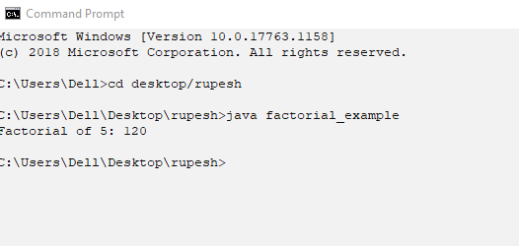

# Write a program that increment the given variable.

## Source code

class incrementexample

{

public static void main(String[] args) {

int a=1,b=2,c,d;

c=++b;

d=a++;

c++;

System.out.println (a+""+b+""+c+""+d);

}

}

## Output window

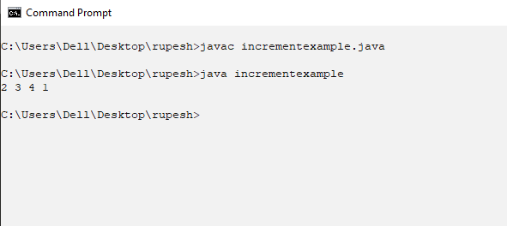

# Write a program of nested-class.

## Source code

class outer

{

int a = 50;

class inner

{

void show()

{

System.out.println("value of a is: "+a);

}

}

void display()

{

inner ob = new inner();

ob.show();

}

}

class inner_example

{

public static void main(String[]args){

outer out = new outer();

out.display();

}

}

## Output window

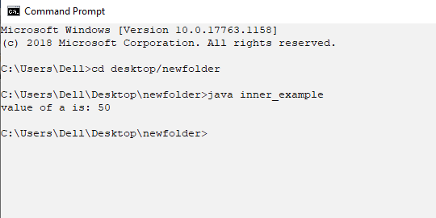

# Write program to return the Boolean .

## Source code

class return_demo

{

public static void main(String[] args) {

boolean b=true;

System.out.println("Before return");

if(b)

return;

System.out.println("After return");

}

}

## Output window

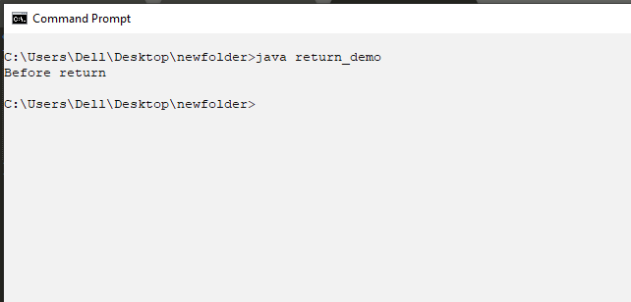

# Write a program that display the length of room less than 15

## Source code

class room

{

int length,breath,height;

void set(int l,int b, int h)

{

length=l; breath=b;height=h;

}

void show()

{

System.out.println("volume is: "+length*breath*height);

}

}

class room_demo

{

public static void main(String[] args) {

room r[]=new room[7];

int i;

for(i=0;i<7;i++)

{

r[i]=new room();

}

r[0].set(20,10,5);

r[1].set(10,8,5);

r[2].set(18,15,10);

r[3].set(5,3,4);

r[4].set(16,11,6);

r[5].set(19,17,3);

r[6].set(12,8,4);

for(i=0;i<7;i++)

{

if (r[i].length<15)

r[i].show();

}

}

}

## Output window

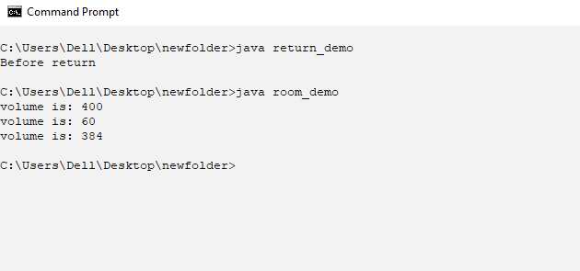

# Write a program of static keyword .

## Source code

/*static keyword*/

class static_demo

{

static int a = 100;

static int b;

static void show(int c)

{

System.out.println(a+""+b+""+c);

}

static

{

System.out.println("Static Block");

b= a+50;

}

public static void main(String[]args){

show(200);

}

}

## Output window

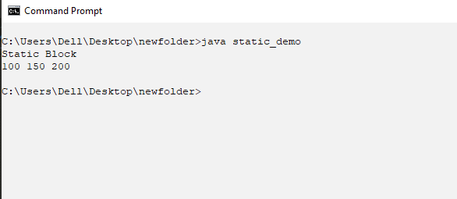

# Write program that display the switch program.

## Source code

import java.util.Scanner;

class user_input

{

public static void main(String[] args) {

String name; int age,roll;

float height; char gender;

Scanner s = new Scanner(System.in);

System.out.println("enter your name: ");

name = s.nextLine();

System.out.println("enter age and roll: ");

age = s.nextInt();

roll = s.nextInt();

System.out.println("enter your height: ");

height = s.nextFloat();

System.out.println("enter your gender: ");

gender = s.next().charAt(0);

System.out.println(name+""+age+""+roll+""+height+""+gender);

}

}

## Output window

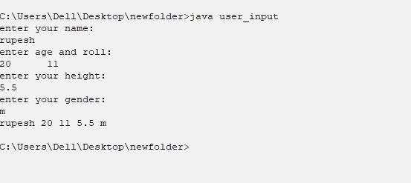

# Write a program that display default constructor.

## Source code

class rectangle

{

int length,breadth;

rectangle()/*this is default constructor*/

{

System.out.println("This is a constructor");

}

rectangle(int length, int breadth)/*this is parameterized constructor*/

{

this.length = length;

this.breadth = breadth;

System.out.println("Area: "+length*breadth);

}

}

class xyz

{

public static void main(String[]args)

{

rectangle ob1 = new rectangle(15,9);/*this is parameterized constructor*/

rectangle ob2 = new rectangle();/*this is default constructor*/

}

}

## Output window

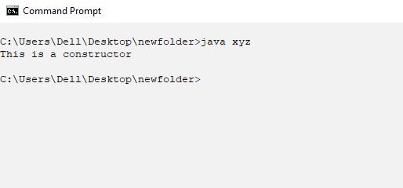

# Write program display name and salary by using balance(string ,int).

## Source code

class balance

{

String name;

int bal;

balance(String n, int b)

{

name = n;

bal = b;

System.out.println(name+""+bal);

}

}

class xyz_demo

{

public static void main(String[] args)

{

balance ob[] = new balance[3];

ob[0] = new balance("Ram",12345);

ob[1] = new balance("Shyam",20000);

ob[2] = new balance("Rupesh",15000);

}

}

## Output window

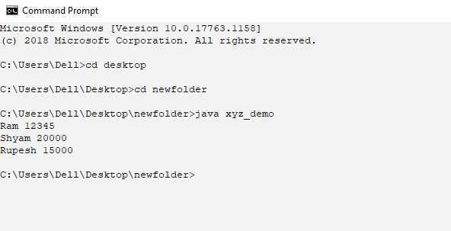

# Write program to check a number is even or odd.

## Source code

class vowel

{

public static void main(String [] args) {

char a='a';

if(a=='a'||a=='e'||a=='i'||a=='o'||a=='u'||a=='A'||a=='E'||a=='I'||a=='O'||a=='U')

System.out.println("it is vowel ");

else

System.out.println("it is not vowel ");

}

}

## Output window

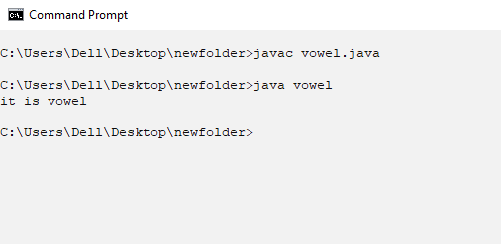

# Write a program of Two D array

## Source code

class twodarray

{

public static void main(String[] args) {

int arr[][] = new int[4][4];

int i,j,k=1;

for(i=0;i<4;i++)

for (j=0;j<i+1 ;j++ ) {

arr[i][j]=k;

k=k+2;

}

for(i=0;i<4;i++){

for (j=0;j<i+1 ;j++ ) {

System.out.print (arr[i][j]+"");

System.out.println();

}

}

}

}

## Output window

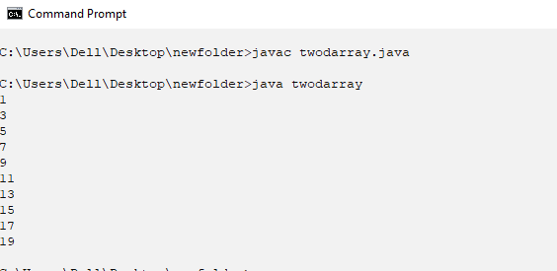

# Write super keyword to call constructor.

## Source code

class base

{

int length,breadth;

base (int l, int b)

{

length=l;

breadth=b;

System.out.println("Area of room:"+(length*breadth));

}

}

class derived extends base

{

int height;

derived (int l,int b)

{

super(l,b);

}

derived (int l,intb,int h)

{

super(l,b);

height=h;

System.out.println("heigth of room:"+height);

System.out.println("volume of room:"+(length*breadth*height));

}

}

class constructor_demo

{

public static void main(String []args)

{

derived ob1=new derived (10,15);

derived ob=new derived (10,5,2);

}

}

## Output window

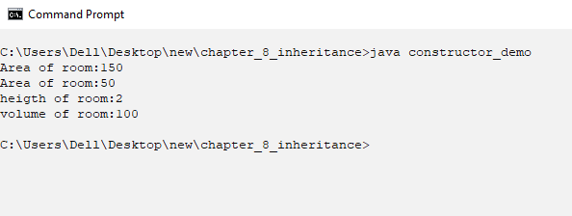

# Write dynamic_polymorphism.

## Source code

class A

{

void abc()

{

System.out.println("kcmit");

}

}

class B extends A

{

void abc()

{

System.out.println("1234");

}

}

class dynamic_polymorphism

{

public static void main(String []args)

{

A a=new A();

B b=new B();

A ref;

ref=a;

ref.abc();

ref=b;

ref.abc();

}

}

## Output window

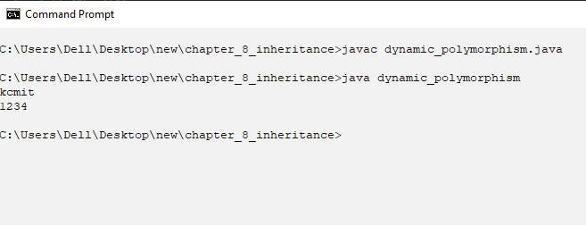

# Write method overriding

## Source code

class A

{

void display()

{

System.out.println("it is super class method");

}

}

class B extends A

{

void display()//override the display method of super class

{

System.out.println("it is sub class method");

}

}

class method_overriding

{

public static void main(String []args)

{

B a= new B();

a.display();

}

}

## Output window

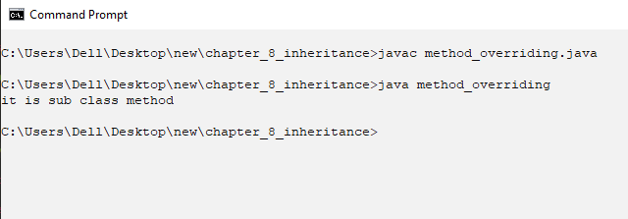

# Write one superclass with multiple subclass

## Source code

//one superclass multiple subclass

class one

{

int length;

one(int l)

{

length=l;

show1();

}

void show1()

{

System.out.println("length of room:"+length);

}

}

class two extends one

{

int breadth;

two(int l,int b)

{

super(l);//one(int l)

breadth=b;

show2();

}

void show2()

{

System.out.println("breadth of room:"+breadth);

}

}

class three extends two

{

int height;

three (int l,intb,int h)

{

super(l,b);//call two(int l,int b)

height=h;

show3();

System.out.println("volume of box:"+(length*breadth*height));

}

void show3()

{

System.out.println("height of box:"+height);

}

}

class multi_constructor

{

public static void main(String []args)

{

three ob=new three(2,2,2);

System.out.println("length "+(ob.length));

}

}

## Output window

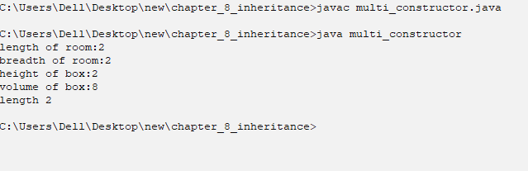

# Write an example of runtime polymorphism

## Source code

class info

{

String name;int age;

info(String s, int a)

{

name=s;

age=a;

}

void display()

{

System.out.println("name: "+name+" age:"+age);

}

}

class overriding extends info

{

int phone;

overriding(String s,inta,intph)

{

super(s,a);

phone=ph;

}

void display()//method overridden

{

System.out.println("name: "+name+" age:"+age+" phone no:"+phone);

}

}

class runtime_polymorphism

{

public static void main(String []args)

{

info ob1=new info("Ram",20);

overriding ob=new overriding("Aashish",19,222222);

info ref;

ref=ob1;//upcasting

ref.display();//print the method of superclass:info as ob1 is object of superclass

ref=ob;//upcasting

ref.display();//print the method of subclass only as ob is object of subclass:overriding

}

}

## Output window

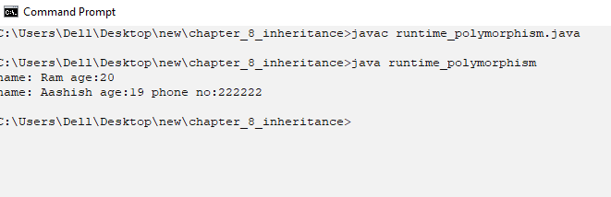

# Write super keyword on method overriding.

## Source code

//use of super keyword on method overriding

class info

{

String name;int age;

info(String s, int a)

{

name=s;

age=a;

}

void display()

{

System.out.print("name: "+name+" age:"+age);

}

}

class overriding extends info

{

int phone;

overriding(String s,inta,intph)

{

super(s,a);

phone=ph;

}

void display()//method overridden

{

super.display();//super keyword is used to call super class method

System.out.println(" phone no:"+phone);

}

}

class super_method_overriding

{

public static void main(String []args)

{

overriding ob=new overriding("Aashish",19,222222);

ob.display();

}

}

## Output window

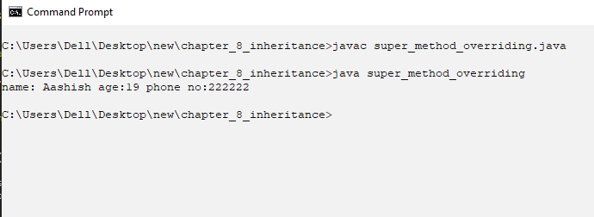

# Write arthematic_try -catch.

## Source code

class arthematic_trycatch

{

public static void main(String []args)

{

System.out.println("before");

try{

int a=10/0;

System.out.println(+a);

}catch(Exception e){

System.out.println("error found :"+e);

}

System.out.println("after");//exception is handeled so this line will also be print

}

}

## Output window

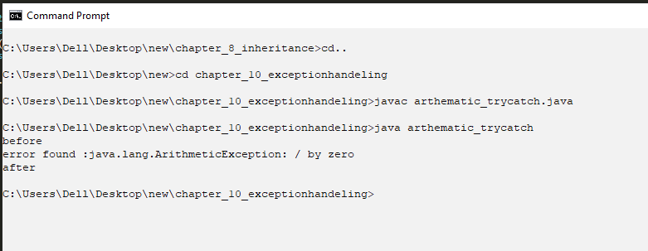

# Write multiple exception with multiple catch

## Source code

class multi_exception{

public static void main(String []args){

System.out.println("before");

try{

int b[]=new int[3];

b[10]=9;

int a=5/0;

}

catch (ArithmeticExceptiona){

System.out.println(a);

}

catch(ArrayIndexOutOfBoundsException e){

System.out.println(e);

}

System.out.println("after");

}

}

//only ArrayIndexOutOfBoundsException will be handeled as it is in first in try

## Output window

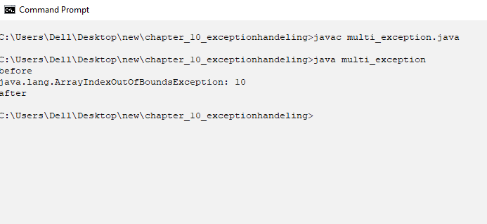

# Write a program to show nested try-catch.

## Source code

//nested try

class nested_try

{

public static void main(String []args){

System.out.println("before");

try{

try{

int b[]=new int[3];

b[9]=8;

}catch(Exception e){

System.out.println("exception caught"+e);

}

int a=5/0;

}catch(ArithmeticException a){

System.out.println("exception caught"+a);

}

System.out.println("after");

}

}

## Output window

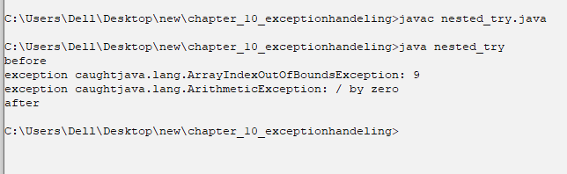

# Write throw exception.

## Source code

//throw exception

import java.util.Scanner;

class A{

int b;

void demo(int a)

{

b=a;

if (b<18){

throw new ArithmeticException("error");

}

else{

System.out.println("hello");

}

}

}

class throw_demo{

public static void main(String []args){

Scanner s=new Scanner(System.in);

System.out.println("enter age");

int age=s.nextInt();

A ob=new A();

ob.demo(age);

}

}

## Output window

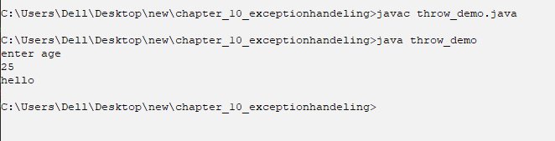

# Take a input from user and make Input output file

## Source code

import java.io.*;

import java.util.Scanner;

class fill

{

public static void main(String[]args)throws IOException

{

try

{

FileWriterfw=new FileWriter("Emp.txt");

BufferedWriterbw= new BufferedWriter(fw);

String name,id,DOB;

Scanner scan=new Scanner(System.in);

System.out.print("Enter name,id and Dob: ");

name=scan.nextLine();

id=scan.nextLine();

DOB=scan.nextLine();

bw.write(id);

bw.write(DOB);

bw.write(name);

bw.close();

}

catch(Exception e)

{

System.out.println(e);

}

try

{

FileReaderfr = new FileReader("Emp.txt");

BufferedReaderbr = new BufferedReader(fr);

String msg=null;

while((msg=br.readLine())!=null)

{

System.out.println(msg);

}

br.close();

}catch(Exception e)

{

System.out.println(e);

}

}

}

## Output window

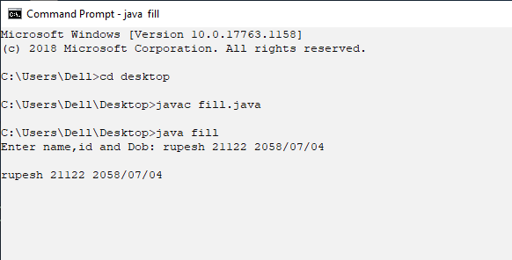

Contents

1 Write programto use access control in java. 1

1.1 Source Code 1

1.2 Output Window 2

2 Write program to display average. 3

2.1 Source Code 3

2.2 Output Window 3

3 Write program to use break. 4

3.1 Source code 4

3.2 Output window 4

4 Write program to terminate break. 5

4.1 Source code 5

4.2 Output window 5

5 Write program to call by value. 6

5.1 Source code 6

5.2 Output window 6

6 Write a program that display Ambiguity in varargs method. 7

6.1 Source code 7

6.2 Output window 8

7 Write program that take college name and display. 9

7.1 Source code 9

7.2 Output window 10

8 Write a program that take college name and display using this keyword. 11

8.1 Source code 11

8.2 Output window 12

9 Write a varargs program. 13

9.1 Source code 13

9.2 Output window 13

10 Write a programto use continue in program. 14

10.1 Source code 14

10.2 Output window 14

11 Write a program of Do while example. 15

11.1 Source code 15

11.2 Output window 15

12 Write a program that take doctors details. 16

12.1 Source code 16

12.2 Output window 17

13 Write a factorial program . 18

13.1 Source code 18

13.2 Output window 18

14 Write a program that increment the given variable. 19

14.1 Source code 19

14.2 Output window 19

15 Write a program of nested-class. 20

15.1 Source code 20

15.2 Output window 21

16 Write program to return the Boolean . 22

16.1 Source code 22

16.2 Output window 22

17 Write a program that display the length of room less than 15 23

17.1 Source code 23

17.2 Output window 24

18 Write a program of static keyword . 25

18.1 Source code 25

18.2 Output window 25

19 Write program that display the switch program. 26

19.1 Source code 26

19.2 Output window 27

20 Write a program that display default constructor. 28

20.1 Source code 28

20.2 Output window 29

21 Write program display name and salary by using balance(string ,int). 30

21.1 Source code 30

21.2 Output window 31

22 Write program to check a number is even or odd. 32

22.1 Source code 32

22.2 Output window 32

23 Write a program of Two D array 33

23.1 Source code 33

23.2 Output window 33

24 Write super keyword to call constructor. 34

24.1 Source code 34

24.2 Output window 35

25 Write dynamic_polymorphism. 36

25.1 Source code 36

25.2 Output window 37

26 Write method overriding 38

26.1 Source code 38

26.2 Output window 38

27 Write one superclass with multiple subclass 39

27.1 Source code 39

27.2 Output window 40

28 Write an example of runtime polymorphism 41

28.1 Source code 41

28.2 Output window 42

29 Write super keyword on method overriding. 43

29.1 Source code 43

29.2 Output window 44

30 Write arthematic_try -catch. 45

30.1 Source code 45

30.2 Output window 45

31 Write multiple exception with multiple catch 46

31.1 Source code 46

31.2 Output window 46

32 Write a program to show nested try-catch. 47

32.1 Source code 47

32.2 Output window 47

33 Write throw exception. 48

33.1 Source code 48

33.2 Output window 48

34 Take a input from user and make Input output file 49

34.1 Source code 49

34.2 Output window 50